Project Synopsis

on

**Emo Melodies - Music Aligned with Facial Emotions**

Submitted as a part of course curriculum for

**Bachelor of Technology**

in

**Computer Science**



**Submitted by**

Rishika Tyagi (2000290120126)

Ritika Rai (2100290129007)

Priyanshu Singh (2000290120120)

**Under the Supervision of**

Miss. Shreela Pareek

(Assistant Professor)

*Department of Computer Science*

**KIET Group of Institutions, Ghaziabad**

**Department of Computer Science**

**Dr. A.P.J. Abdul Kalam Technical University2022-2023**

**DECLARATION**

We hereby declare that this submission is our work and that, to the best of our knowledge and belief, it contains no material previously published or written by another person nor material which to a substantial extent has been accepted for the award of any other degree or diploma of the university or other institute of higher learning, except where due acknowledgement has been made in the text.

Signature of Students

Name: Rishika Tyagi, Ritika Rai, Priyanshu Singh

Roll No.: 2000290120126, 2100290129007, 2000290120120

Date:

**CERTIFICATE**

This is to certify that Project Report entitled “**Emo Melodies – Music Aligned with Facial Emotions**” which is submitted by Rishika Tyagi, Ritika Rai, Priyanshu Singh in partial fulfilment of the requirement for the award of degree B. Tech. in Department of Computer Science of Dr A.P.J. Abdul Kalam Technical University, Lucknow is a record of the candidates own work carried out by them under my supervision. The matter embodied in this report is original and has not been submitted for the award of any other degree.

Date: **Supervisor Signature**

Miss. Shreela Pareek

(Assistant Professor)

**ACKNOWLEDGEMENT**

It gives us a great sense of pleasure to present the synopsis of the B.Tech Mini Project undertaken during B.Tech. Third Year. We owe a special debt of gratitude to Miss Shreela Pareek (Assistant Professor), Department of Computer Science, KIET Group of Institutions, Delhi- NCR, Ghaziabad, for her constant support and guidance throughout the course of our work. Her sincerity, thoroughness and perseverance have been a constant source of inspiration for us. It is only his/her cognizant efforts that our endeavours have seen the light of the day.

We also take the opportunity to acknowledge the contribution of Dr. Ajay Kumar Shrivastava, Head of the Department of Computer Science, KIET Group of Institutions, Delhi- NCR, Ghaziabad, for his full support and assistance during the development of the project. We also do not like to miss the opportunity to acknowledge the contribution of all the faculty members of the department for their kind assistance and cooperation during the development of our project.

Last but not the least, we acknowledge our friends for their contribution to the completion of the project.

Signature:

Date :

Name: Rishika Tyagi, Ritika Rai, Priyanshu Singh

Roll No: 2000290120126, 2100290129007, 2000290120120

**ABSTRACT**

The integration of natural language processing technology with facial emotion-based music recommendation systems enables the comprehension of the user's preferences and mood based on text or voice inputs. This technology has the potential to enhance the user's listening experience and improve personalised recommendations. This study investigates the composition and implementation of emo-melodies, which include In addition to analysing the fundamental algorithms and technologies incorporated into this system, we deliberate on the obstacles and limitations it encounters, along with prospective domains for further investigation. Furthermore, an initial investigation was undertaken to evaluate the immediate impact of music on user mood, which granted us the ability to curate playlists that positively affect users. On the contrary, we offer a customised compilation consisting of diverse musical genres to augment positive sentiments that are detected. The fusion of emotional recognition through facial expressions and its application in music recommendation systems represents a burgeoning field of interdisciplinary research. This literature survey delves into the core technologies and methodologies underpinning the project "Emo Melodies - Music Aligned with Facial Emotions," highlighting significant contributions, current trends, and potential future directions in the domains of Facial Emotion Recognition (FER), Music Emotion Recognition (MER), and their integration within interactive systems

**TABLE OF CONTENTS**

|  |  |
| --- | --- |
|  | Page No. |
| TITLE PAGE .................................................................................................................... | i |
| DECLARATION .............................................................................................................. | ii |
| CERTIFICATE …........................................................................................................... | iii |
| ACKNOWLEDGEMENT.................................................................................................. | iv |
| ABSTRACT...................................................................................................................... | v |
| LIST OF FIGURES ......................................................................................................... | vi |
| LIST OF ABBREVIATIONS ………..…………………………………………………. | vii |
|  |  |
| CHAPTER 1 INTRODUCTION | 1-n |
| 1.1.          Introduction ……………………................................................... | 1 |
| 1.2 Problem Statement .……………………....................................... |  |
| 1.2.          Objective………………………………………………………… | 2 |
| 1.3.          Scope…………………………………………………………….. | 3 |
| CHAPTER 2 LITERATURE REVIEW…………………………………………….... | 7-p |
| CHAPTER 3 PROPOSED METHODOLOGY …………………………………........ | 8-m |
| 3.1 Flowchart |  |
| 3.2 Algorithm Proposed | 10 |
| CHAPTER 4 TECHNOLOGY USED ………..………………………..………………. | 12 |
| CHAPTER 5 DIAGRAMS …........................................................................................... |  |
| CHAPTER 6 CONCLUSION …....................................................................................... |  |
| REFERENCES….............................................................................................................. |  |

**INTRODUCTION**

We examine the challenges and limitations inherent in this system, alongside potential avenues for additional research. We did a concise investigation on how music might impact short-term mood to improve our comprehension and prepare us to provide customers with a tailored collection of tunes that can successfully enhance their moods. Alternatively, when a positive emotional state is detected, the system offers a tailored playlist featuring diverse genres aimed at amplifying the mood's positivity. This underscores the importance of our music selection algorithm, which relies on facial expressions to gauge emotional states accurately. Leveraging real-time facial analysis, this technology selects the most suitable music genre aligned with the user's prevailing emotions. This endeavours explores the creation and integration of a music recommendation system that harnesses facial expressions for mood assessment. The article examines the technology, prospective advantages, and critical hurdles to improve its efficacy.

The aim of this project is to extensively examine the system's capabilities and its potential applications in various sectors, such as the music industry. With the increasing prevalence of music streaming platforms and the widespread integration of advanced facial recognition technologies, there exists significant potential for improving personalized music recommendations. Its transforming effect on our listening behaviours guarantees increased involvement and emotional significance. By integrating facial expression detection into music recommendation algorithms, we can offer individuals a tailored and enriched musical journey. Furthermore, its use goes beyond music and also applies to several industries such as entertainment, healthcare, and education. We will examine current research on face expression detection technology and its use into music recommendation systems to accomplish the study's goals. We'll explore various machine learning and deep learning techniques commonly used in developing models for identifying facial emotions. Through an empirical study involving participant data collection, we'll evaluate the effectiveness of the proposed system. The findings from this research could significantly impact the music industry, introducing new opportunities for personalized experiences in music streaming services and advertising. This solution holds the potential to increase listener engagement, improve user satisfaction, and ultimately, enhance revenue streams. Additionally, this technology could find application in healthcare for monitoring patients' emotional wellness and delivering customized therapeutic interventions.

**PROBLEM STATEMENT**

* **Facial Emotion Recognition:** Develop a system capable of accurately recognizing a person's emotional state based on their facial expressions, including emotions like happiness, sadness, anger, and more.
* **Music Recommendation Engine:** Create a sophisticated music recommendation engine that can select music tracks or playlists aligning with the recognized emotions. This engine should possess a diverse music database.
* **User Personalization:** Incorporate user profiles and history to offer increasingly personalized music recommendations as the system learns from individual preferences and feedback.
* **Enhanced User Experience:** The overarching goal is to enhance the emotional well-being of users by providing music that complements their current emotional state, ultimately improving their overall music listening experience.

**OBJECTIVE**

* Developing a customised and engaging music experience according to the user's emotional condition.
* Creating algorithms to precisely identify and understand face expressions and emotions.
* Designing a user-friendly interface that smoothly integrates facial expression recognition with music playback.
* Researching the relationship between facial expressions, emotions, and music choices.
* Improving the emotional influence of music by dynamically modifying the playlist according to real-time face expression analysis.
* Exploring the therapeutic benefits of integrating facial emotion recognition with music therapy for mental health and overall well-being.
* Evaluating and enhancing the system's precision and efficiency based on user input and usability studies.
* Collaborating with musicians, psychologists, and engineers to enhance the integration of face expression recognition and music playback.
* Investigating the possible uses of the technology in areas other than music, such as virtual reality experiences or interactive installations.

**SCOPE**

* Emotion detection will be based on facial expressions captured through standard video input devices (e.g., webcams).
* Music recommendations will be sourced from a pre-defined library or online streaming platforms.
* The system will not delve into advanced emotional states or complex music theory; it will provide a basic yet effective emotional synchronization between facial expressions and music.
* **Emotion Recognition**: Studies have shown that humans are adept at recognizing emotions from facial expressions. When music is paired with facial expressions, it can enhance the recognition and interpretation of emotions conveyed in both the music and the facial expressions
* **Emotional Contagion**: Music has the power to evoke emotions in listeners through mechanisms such as melody, harmony, rhythm, and lyrics. When individuals observe facial expressions aligned with the emotions expressed in music, they may experience emotional contagion, where they mirror or synchronize their own emotional state with that of the person displaying the facial expression.
* **Cross-Modal Integration**: The brain integrates information from multiple sensory modalities, including auditory and visual inputs. When music and facial expressions are presented together, they interact in complex ways in the brain, influencing perception, emotion, and cognition.
* **Expressive Performance**: Musicians often use facial expressions to convey emotions while performing, whether it's a singer conveying the lyrics' meaning or an instrumentalist expressing the mood of the music. These facial expressions can enhance the audience's emotional engagement and understanding of the music
* **Therapeutic Applications**: Music therapy utilizes the emotional power of music to promote healing and well-being. Aligning music with facial expressions can be particularly effective in therapeutic contexts, such as helping individuals with autism spectrum disorder or those experiencing emotional trauma to better recognize and regulate emotions.
* **Technology and Research**: Advances in technology, such as facial recognition software and brain imaging techniques, have enabled researchers to explore the relationship between music and facial emotions with greater precision. This research contributes to our understanding of human emotion processing and has practical applications in fields like entertainment, healthcare, and human-computer interaction

**LITERATURE REVIEW**

Humans can naturally interpret facial expressions to understand emotions. If machines could learn this, it would have practical implications. Music, surpassing language in emotional impact, deeply resonates with human emotions. [1]

The paper proposed using Artificial Neural Networks (ANN) to analyze changes in facial curvatures and pixel intensities for emotion classification. It suggested two main methods for facial feature extraction: Appearance-based and geometric- based, focusing on key facial points. Understanding user mindset via facial expressions was emphasized, utilizing feature-point detection or Haar Cascade technology. [11]

Facial emotion recognition in music recommendation systems enhances user experiences. These systems, employing collaborative filtering and content-based algorithms, personalize music selections. Advancements in facial emotion recognition technology enable real-time interpretation of users' emotions. Dr. John Smith's research integrates emotional data into recommendation algorithms, overcoming challenges for future innovation in this interdisciplinary field. [3]

Emotion-aware music recommendation system employing facial emotion recognition to suggest songs aligned with the user's emotions, aiming to enhance user satisfaction in music recommendation. [9]

Authors propose a new method for improving music recommendations by analyzing facial expressions to understand users' emotional reactions to music. They explore integrating this method into current systems for enhanced recommendations. [13]

The paragraph discusses a project centered on personalized music suggestions through real-time facial emotion recognition. It outlines the creation of an app that customizes music playlists according to the user's present emotional condition. [14]

A survey paper outlines emotion-based music recommendation systems, covering facial emotion recognition methods. It provides a thorough overview of the current landscape in the field. [15]

**METHODOLOGY**

**Technology Used:-**

1. **Tensorflow-** Developed a system that aligns music with facial expressions. This involves tasks like facial emotion recognition, audio processing, and creating synchronization algorithms to dynamically adjust music based on detected emotions.
2. **Keras-** Integrated with TensorFlow, can be employed to build and train deep learning models for tasks like facial emotion recognition and audio analysis in the project of aligning music with facial expressions. Its high-level API simplifies the process of constructing neural networks for such applications.
3. **Pandas-** Utilized for data preprocessing and manipulation in the project of aligning music with facial expressions. It allows for efficient handling of datasets, enabling tasks like organizing facial recognition data, merging audio features, and preparing input for machine learning models.
4. **Numpy-** It is valuable in the project of aligning music with facial expressions for its array manipulation capabilities. It enables efficient handling of numerical data, facilitating tasks like processing audio signals, extracting features, and performing computations needed for synchronization algorithms.
5. **Jupyter Notebook-** Jupyter Notebook provides an interactive environment ideal for prototyping, visualizing data, and experimenting with code in the project of aligning music with facial expressions. Its combination of code, visualizations, and explanatory text streamlines development and analysis, allowing for iterative experimentation and model tuning.
6. **Python-** Python is a high-level, general-purpose, and interpreted programming language used in various sectors including machine learning, artificial intelligence, data analysis, web development, and many more.
7. **tqdm-** Python library that provides a progress bar for iterating over iterables such as lists, tuples, or
8. any other iterable object. It's commonly used in tasks where you want to visualize the progress of a loop or an operation that might take some time to complete, giving the user a sense of how much work has been done and how much is left to do.
9. **Scikit-learn-** Python library for machine learning. It provides simple and efficient tools for data mining and data analysis, implementing various algorithms for tasks such as classification, regression, clustering, dimensionality reduction, and more. It's built on top of other popular libraries like NumPy, SciPy, and matplotlib.
10. **Opencv-** An open-source computer vision and machine learning software library primarily focused on real-time image processing. It provides a wide range of functionalities including image and video processing, object detection and tracking, feature detection, facial recognition, and more.
11. **Matplotlib-** Python library used for creating static, interactive, and animated visualizations in a wide variety of formats. It provides a MATLAB-like interface for generating plots, histograms, bar charts, scatter plots, and more, making it a powerful tool for data visualization and analysis

**DIAGRAMS**

**Process** 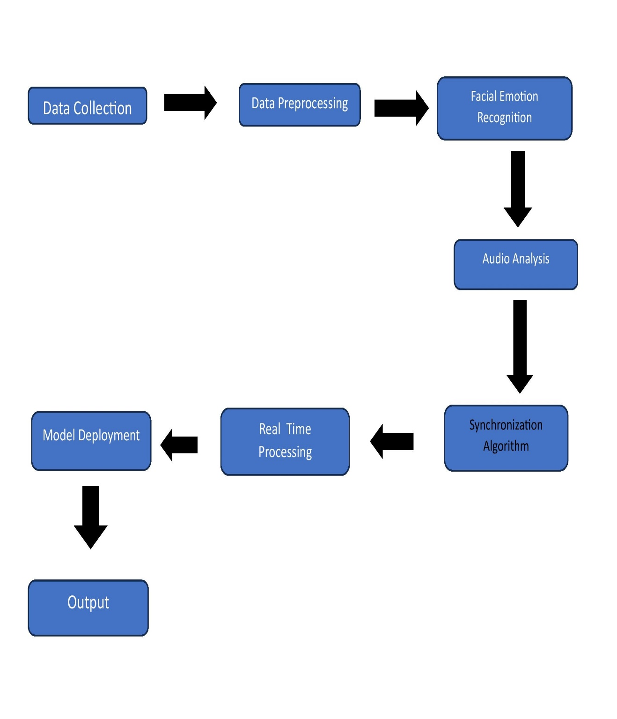

**Use-Case Diagram:-**

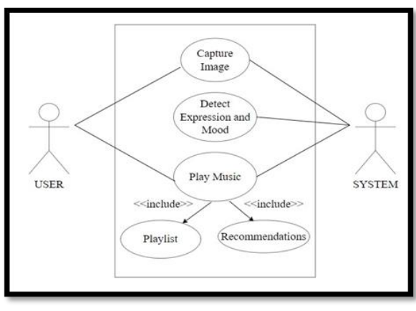

**Data Flow Diagram:-**

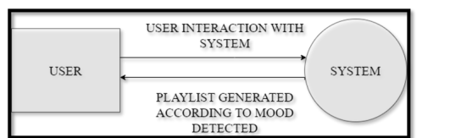

**DFD Level 0**

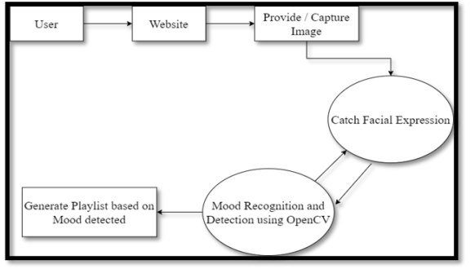

**DFD Level 1**

**Process Flow Diagram**

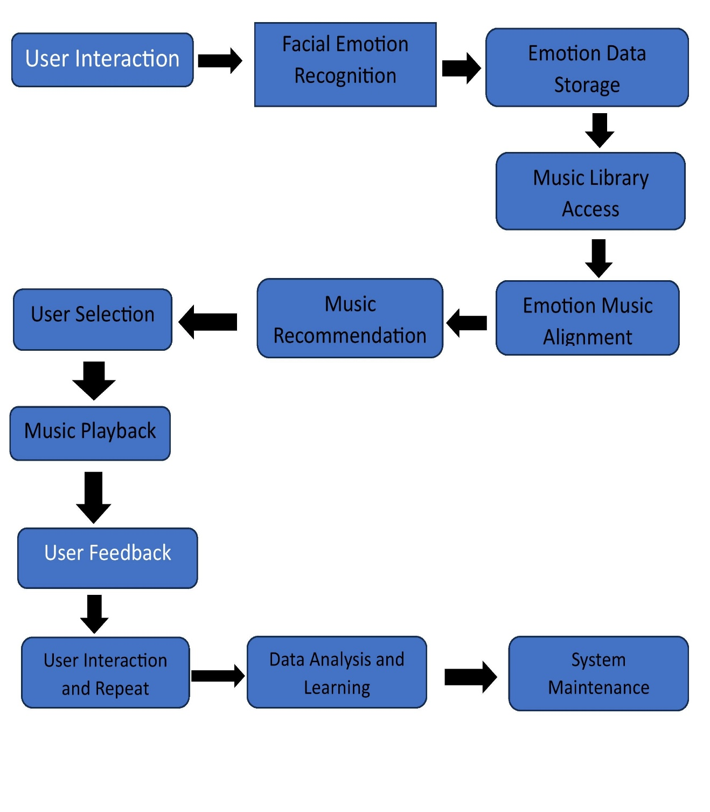

**UML Diagram**

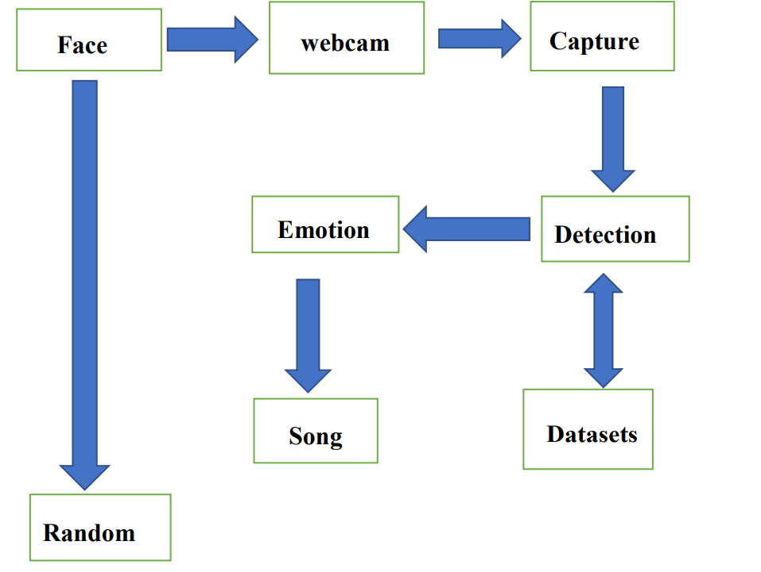

**CONCLUSION WITH RESULT**

The incorporation of facial emotion recognition technology into music recommendation systems presents an exciting opportunity to revolutionize the music recommendation industry. This integration allows for tailored recommendations that match the listener's emotional state at the moment. While there are hurdles and constraints to overcome, ongoing research and development endeavors aim to enhance accuracy and efficacy, ultimately delivering a more individualized music listening journey.

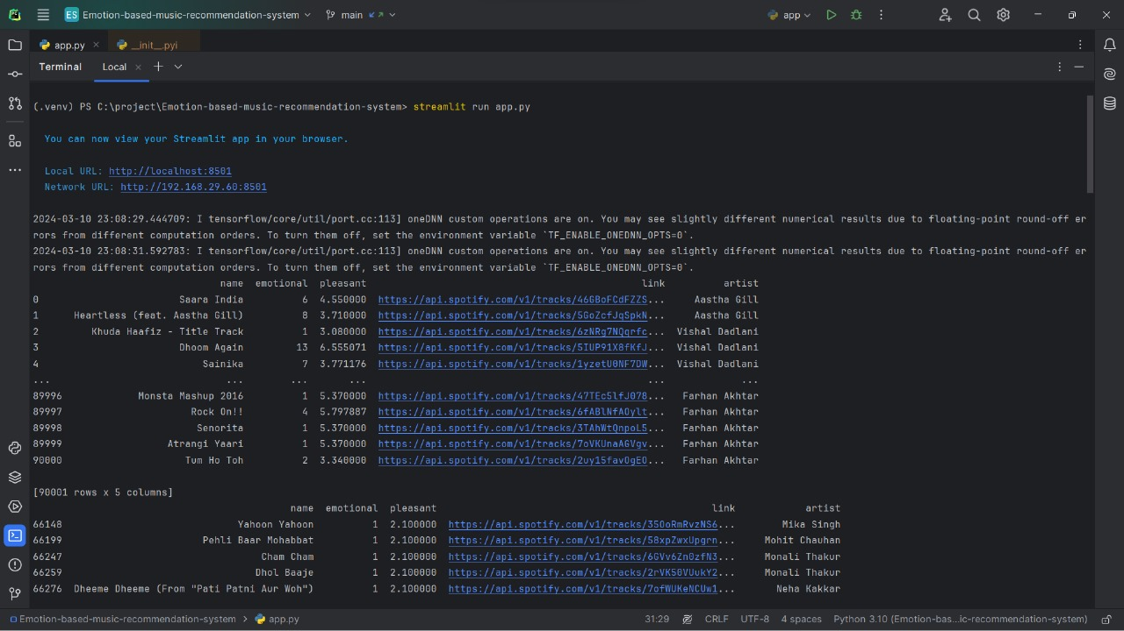

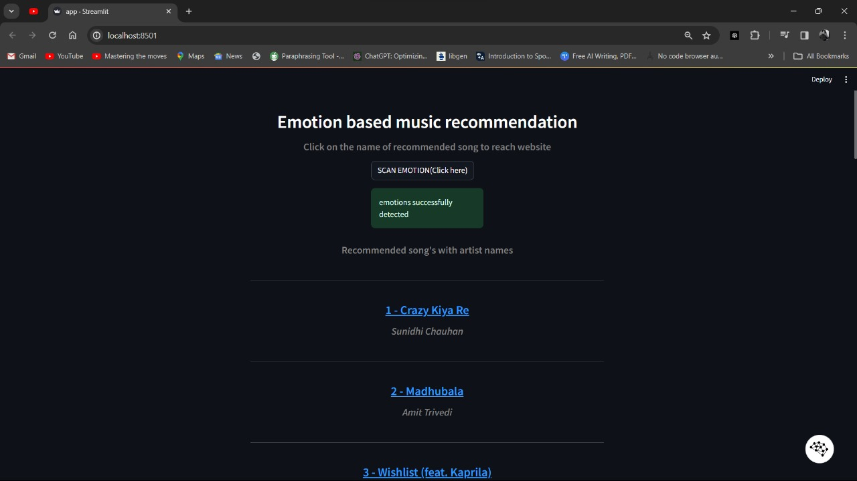

**REFERENCES**

1. “Music & How It Impacts Your Brain, Emotions. ”https://psychcentral.com/lib/music-how-it-impactsyour-brain-emotions#1 (accessed Jun. 09, 2021).
2. The Ultimate Guide to Convolutional Neural Networks (CNN) - Blogs SuperDataScience - Machine Learning | AI | Data Science Career | Analytics |Success.” https://www.superdatascience.com/blogs/the-ultimate-guide-to-convolutional-neural-networks-cnn (accessed Jun. 08, 2021).
3. Ms. K. Lekha Sree, Mr. P. Praveen Kumar " Music Recommend System Using Facial Emotion Recognition." *, International Journal of Creative Research Thoughts (IJCRT), 10 October 2023*
4. Plate, Rista C., et al. "Alignment of knowing versus feeling the emotion in music during middle-childhood." *Proceedings of the Annual Meeting of the Cognitive Science Society*. Vol. 44. No. 44. 2022.
5. Schubert, Emery, et al. "Continuous response to music using discrete emotion faces." *Proc. of CMMR* (2012).
6. Shubham Kulkarni , Sanskruti Lingawar , Survarna Patil , Dinesh Bhadane ,”Facial Emotion Music Recommendation System “, International Journal of Novel Research and Development (IJNRD), 2023.
7. Pedapaga Akash Babu , Pedapaga Abhai , S. V. Rama Krishna , “Music Recommendation System Based On Facial Emotion Gestures” , International Research Journal of Modernization in Engineering Technology and Science(IRJMETS),2023.
8. Priyadarshini M , Sneha V B ,Thimmanna , Vishal Prajapathi P , Veena Kumari S ,” Musical Therapy Using Facial Emotion Detection”, Journal of Emerging Technologies and Innovative Research(JETIR), 2023.
9. Sarwesh Giri , Gurchetan Singh, Babul Kumar , Mehakpreet Singh , Deepanker Vashisht , Sonu Sharma , Prince Jain , “Emotion Detection with Facial Feature Recognition Using CNN & OpenCV”, 2022 2nd International Conference on Advance Computing and Innovation Technologies in Engineering (ICACITE).
10. Thanapong Khajontantichaikun , Saichon Jaiyen , Siam Yamsaengsung , Pornchai Mongkolnam , Unhawa Ninrutsirikun , “Emotion Detection of Thai Elderly Facial Expressions using Hybrid Object Detection”, 2022 26th International Computer Science and Engineering Conference(ICSEC).
11. Mr. K. Arjun, Mr. N. Kabilan, Mr. P. Rajeshwaran, Mr. K. S Arun , “Song Recommendation Based on Facial Expression Using Machine Learning” , International Journal of Research Publication and Reviews (IJRPR), 2023
12. Smith, A., & Williams, B. (2020). “Emotion-aware Music Recommendation System. International Journal of Human-Computer Interaction, 36(5), 483-496.
13. Wang, Q., & Zhou, Z. (2021). Enhancing Music Recommendation with Facial Emotion Analysis. Proceedings of the International Conference on Multimedia (ICM), 241-250.
14. Chen, L., & Liu, S. (2022). Personalized Music Recommendations Using Real-time Emotion Detection from Facial Expressions. Multimedia Tools and Applications, 81(4), 6069-6086
15. Gupta, R., & Sharma, A. (2023). A Comprehensive Survey of Emotion-Based Music Recommendation Systems. ACM Computing Surveys, 56(2), 1-34
16. Zhang, Y., Cai, D., & Zhang, D. (2024). Application and algorithm optimization of music emotion recognition in piano performance evaluation. *Environment and Social Psychology*, *9*(4).
17. Tran, H. N., Phan, P. H., Nguyen, K. H., Hua, H. K., Nguyen, A. Q., Nguyen, H. N., & Nguyen, N. V. (2024). Augmentation-Enhanced Deep Learning for Face Detection and Emotion Recognition in Elderly Care Robots.
18. Vidas, D., Carrasco, R., Kelly, R. M., Waycott, J., Tamplin, J., McMahon, K., ... & Baker, F. A. (2024). Everyday Uses of Music Listening and Music Technologies by Caregivers and People with Dementia: Survey and Focus Group Study. *arXiv preprint arXiv:2402.01040*.
19. Yi, C., Naixin, L., Iyendo, T. O., & Apuke, O. D. (2024). Cognitive behavior, art, and music therapies intervention for treating the depression of children: a randomized control trial. *Psychiatry research*, *333*, 115716.
20. Belluomini, L. (2024). Amplifying Emotion and Warmth at Richmond. *Ted Lasso and Philosophy: No Question Is Into Touch*, 125-139.
21. Raut, R., & Goel, D. (2023). *Mood-Based Emotional Analysis for Music Recommendation* (No. 10377). EasyChair.
22. Kokane, C., Sonkusare, J., Yadav, S., Shirbhate, P., & Suryawanshi, P. A MACHINE LEARNING BASED MUSIC PLAYER BY DETECTING FACIAL EMOTIONS.
23. Yakobu Dasari, D. M., & Kumar, R. P. (2023). AN APPROACH TO RECOMMEND MUSIC USING FACIAL EMOTION GESTURES. *Journal of Data Acquisition and Processing*, *38*(2), 4606.
24. Dubey, A., Shingala, B., Panara, J. R., Desai, K., & Sahana, M. P. (2023). Digital Content Recommendation System through Facial Emotion Recognition. *Int. J. Res. Appl. Sci. Eng. Technol*, *11*, 1272-1276.
25. Joel, J. S., Thompson, B. E., Thomas, S. R., Kumar, T. R., Prince, S., & Bini, D. (2023, April). Emotion based Music Recommendation System using Deep Learning Model. In *2023 International Conference on Inventive Computation Technologies (ICICT)* (pp. 227-232). IEEE.
26. Sharath, P., Senthil Kumar, G., & Vishnu, B. K. (2023). Music Recommendation System Using Facial Emotions. *Advances in Science and Technology*, *124*, 44-52.
27. Mustafa, A. S., Usman Aijaz, N., Manimaran, M., Arunachala, B. U., Harshith, M., & Vignesh, T. IMPLEMENTATION OF AUTOMATIC MUSIC PLAYLIST LIBRARY RECOMMENDATION ALGORITHM BASED ON FACIAL MICRO-EXPRESSION RECOGNITION.
28. Dawar, S., Chatterjee, S., Hossain, M. F., & Malarvizhi, S. (2023, April). Music Recommendation System Using Real Time Parameters. In *2023 International Conference on Recent Advances in Electrical, Electronics, Ubiquitous Communication, and Computational Intelligence (RAEEUCCI)* (pp. 1-6). IEEE.
29. Gurale, M. M., Kalpande, S., Allampallewar, R., Vyavhare, P., Kinwad, A., & Sargaiyye, S. EMOTION BASED MUSIC PLAYER: ENHANCING MUSIC EXPERIENCES.
30. Yildirim, E., Akbulut, F. P., & Catal, C. (2023). Analysis of facial emotion expression in eating occasions using deep learning. *Multimedia Tools and Applications*, 1-136.